THE SENTRY

Spreadsheet Fantasy’s 16th season is underway and already the leaderboard has shaken up big time! A strong start for the new offseason trade rules, a concerning streak, and a glass half broken are just a few of our week one stories. Let’s dig into the draft and our first week at the Sentry.

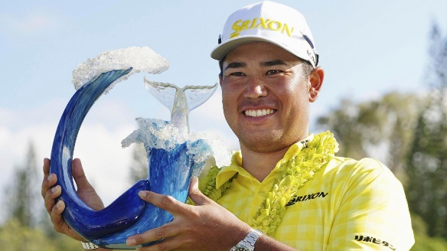
It was a hot start out of the gates for Lawrence, who made the biggest move of the offseason, trading a second-round pick to Jon Mark for Hideki Matsuyama. The trade didn’t take long to pay off, with Matsuyama setting a new scoring record enroute to the first win of the season. He’ll take that momentum into the Sony Open, a tournament he won in 2022. Jhonattan Vegas also showed up with a fourth-place finish after being left off a roster in 2024. The strong first week follows a strong draft, with Lawrence reclaiming some long-time favorites in Keegan Bradley, Justin Rose, Min Woo Lee and Rickie Fowler. We’ll see if getting the gang back together results in a big finish for him.


Top fifteens or better across the board or better for Bryce after one week, with long-time keeper Collin Morikawa coming off his second-best season to date leading the charge at runner-up. Despite the strong year in 2024, he was snake bitten and couldn’t snag a win, much like the rest of Bryce’s boys. That will be an interesting storyline in the early season, as despite a podium finish last year, Bryce is now at 55 consecutive weeks without a win, just 8 short of the record. Even with that looming indignity, he’ll have plenty of opportunities to snap the streak with some strong picks in the early rounds. Maverick McNealy and Sepp Straka should challenge around the Tier 1s, and Morikawa can’t go winless forever (right?).

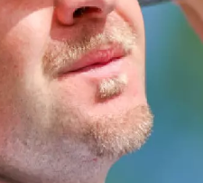
Yours truly was witness to Seumas’ exuberance on Sunday as his carefully selected squad cruised to four top tens and an exceptional start to the season. Mulling over names for days prior to the draft, he mapped out every potential scenario, landing on Corey Conners and Thomas Detry as the ideal first two picks to compliment a strong cornerstone keeper in Ludvig Aberg. All three found the top five, while the scandalously soul patched Harry Hall cracked the top ten. Seumas has a great stable of Major championship performers, and some real high-potential young guns in the middle of the roster. It’s win-now time for the great Scot.

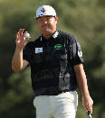
Blessed with a plethora of first overall picks in the LPGA, LIV, and regular drafts, Beast cashed in the former two to freshen up his keepers with Sungjae Im, paying immediate dividends thanks to his third-place finish. A strong start to the new offseason trading rules with both traded players on the podium. Aaron Rai also started the season off right with a top 15, while first-overall pick Akshay Bhatia found the top fifty. Beast will be looking to emulate Bryce from last year, when he went from last to the top three in just one season.

Team CAdaMatt will also no doubt be pleased with his start, despite suboptimal performances from both keepers Homa and Hovland. Cam Davis and Adam Scott both find themselves back on Brent’s team once again, with the latter returning for a 9th season there. They seemed to be fine with the return, both registering top 15 finishes. Cameron Young found himself separated from Mrs. Beast’s team for the first time in his four seasons, and his top ten finish may make her regret moving on. Brent’s season will depend on whether Hovland and Homa can find their groove this year, as he’s running it back despite difficult seasons for both in 2024.

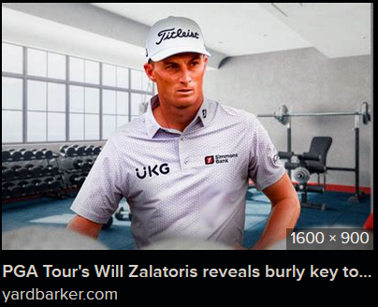
Jon Mark and Daniel make up the first pairing we run into, tied at 50 a piece. Landing a second-round pick for Hideki Matsuyama, Jon came into the season in a strong draft position despite his high finish. He was able to get a couple of his target guys early in Davis Thompson and Rasmus Hojgaard, but it was keeper Sam Burns who carded the highest finish in week one with a top ten. That should help ease the pain of Matsuyama’s trophy in his first week on Lawrence’s squad.
Like Jon, Daniel had both keepers taking the field this week, with Patrick Cantlay and snipe-of-the-draft Austin Eckroat finding the top 15. Will Zalatoris will likely be the wildcard of Daniel’s 2025 hopes, with monster potential and looking absolutely jacked, he’ll try to bounce back from the injury woes that derailed his last couple of seasons. Last year was a step in the right direction, and if he can stay healthy, he could be a force in the Majors.


It's a family affair down in the land of 40 points, with Kevan, Mrs. Beast, and James making up that club. Despite a strong start for Bobby MacIntyre, as well as a handful of top fifties, Kevan’s thoughts will be on Scottie Scheffler’s beautiful hands. For those not in the know, Scheffler injured his hand over Christmas, thanks to an accident with a glass. Presumably he was trying to help his mom bake cookies and smashed the glass really hard and it shattered in the same way I did when I was about two and a half. But unlike two-and-a-half-year-old James, Scottie Scheffler needs those hands to make millions of dollars. The latest news is that he’ll be out at least through the Amex and potentially later, with the news that he had surgery on the hand being particularly concerning. If he’s out for any extended period, Kevan will need the rest of their team to step up to keep the hopes of a threepeat alive.
Mrs. Beast has never really recovered from Daniel taking Austin Eckroat one pick before she was going to, but I suppose Taylor Pendrith matching his top 15 is a decent consolation. 2025 will be a make-or-break year for Mrs. Beast, with many storylines. Will Justin Thomas ever get back to his peak form? Can Tommy Fleetwood break into the elite echelon and win a tournament (or even a Major)? And will she regret moving on from Cam Young if he has a strong breakout season? Only time will tell.
No Rory or Lowry this week for James, so it wasn’t exactly a test of how strong his team is. A top 15 from Wyndham Clark was encouraging, with Matt Fitzpatrick and Max Greyserman finding the top 25. Fitzpatrick in particular will be an interesting character to watch, as he’s just two years removed from a nearly 800 point season. If James is going to take home championship number six, he’ll need big contributions from his top four.

